Hamilton Township School District
90 Park Avenue
Hamilton, New Jersey 08690
Mercer County

Department of Curriculum and Instruction

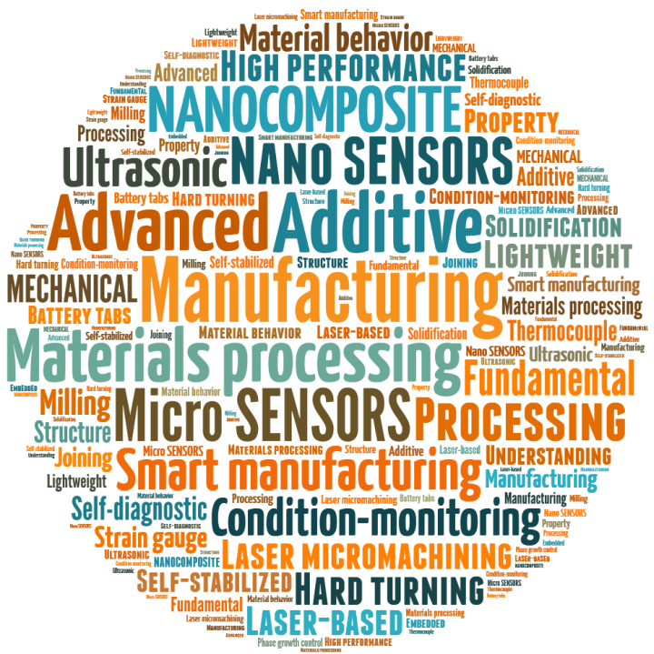

Technology, Engineering & Social Responsibility
Board of Education approved:
Table of Contents
Acknowledgements 1
Introduction: 3
Course Description: 3
Pacing Guide 4
Unit 1: 5

Acknowledgements

Administration
Dr. Scott Rocco Superintendent of Schools
Mr. Anthony Scotto Director of Curriculum & Instruction
Mrs. Joanne Long Supervisor, 6-12 Science & Applied Technology

Committee Members
Greg Paulick Hamilton High School West
Alex Chis-Luca Hamilton High School North
Steven Pae Hamilton High School East

Introduction:
This guide has been prepared to meet the requirements of the Hamilton Township Board of Education and the New Jersey Department of Education. This document will serve as a guide for lesson planning. It sets forth a framework upon which each school can build a program suited both to the needs of the students and to the expectations of the community.

Course Description:
Fill this out

Pacing Guide
Unit | Core Ideas and Standard  Fill out the unit # and name and the core idea of each unit | Approximate Number of Weeks

Unit 1:
Give each unit a name
Essential Questions
List 2-4 essential questions for each unit
Student Learning Objectives
By the end of the unit, the student will be able to:
Use bullet points to list what students will be able to do at the end of each unit to demonstrate mastery
NJ Student Learning Standards
Practices | Disciplinary Core Ideas |  | Performance Expectations
ITEEA Standards for Technological Literacy
STEL Benchmarks | Technology & Engineering Concepts |  | Technology & Engineering Practices
Suggested Learning Activities
Fill out this section with a detailed summary of 3-4 activities students will complete for this unit

Evidence of Learning
Formative  Admit/Exit Tickets  Questions, Questioning, and Discussions  Constructive quizzes  Visual modeling of concepts |  | Summative  Problem-Based Assessments  Unit Projects  Tests

Unit 2:
Essential Questions
Student Learning Objectives
By the end of the unit, the student will be able to:

NJ Student Learning Standards
Practices | Disciplinary Core Ideas |  | Performance Expectations
ITEEA Standards for Technological Literacy
STEL Benchmarks | Technology & Engineering Concepts |  | Technology & Engineering Practices
Suggested Learning Activities
Evidence of Learning
Formative  Admit/Exit Tickets  Questions, Questioning, and Discussions  Constructive quizzes  Visual modeling of concepts |  | Summative  Problem-Based Assessments  Unit Projects  Tests

Unit 3:
Essential Questions
Student Learning Objectives
By the end of the unit, the student will be able to:

NJ Student Learning Standards
Practices | Disciplinary Core Ideas |  | Performance Expectations
ITEEA Standards for Technological Literacy
STEL Benchmarks | Technology & Engineering Concepts |  | Technology & Engineering Practices
Suggested Learning Activities
Evidence of Learning
Formative  Admit/Exit Tickets  Questions, Questioning, and Discussions  Constructive quizzes  Visual modeling of concepts |  | Summative  Problem-Based Assessments  Unit Projects  Tests

Unit 4:
Essential Questions
Student Learning Objectives
By the end of the unit, the student will be able to:

NJ Student Learning Standards
Practices | Disciplinary Core Ideas |  | Performance Expectations
ITEEA Standards for Technological Literacy
STEL Benchmarks | Technology & Engineering Concepts |  | Technology & Engineering Practices
Suggested Learning Activities
Evidence of Learning
Formative  Admit/Exit Tickets  Questions, Questioning, and Discussions  Constructive quizzes  Visual modeling of concepts |  | Summative  Problem-Based Assessments  Unit Projects  Tests

Unit 5:
Essential Questions
Student Learning Objectives
By the end of the unit, the student will be able to:

NJ Student Learning Standards
Practices | Disciplinary Core Ideas |  | Performance Expectations
ITEEA Standards for Technological Literacy
STEL Benchmarks | Technology & Engineering Concepts |  | Technology & Engineering Practices
Suggested Learning Activities
Evidence of Learning
Formative  Admit/Exit Tickets  Questions, Questioning, and Discussions  Constructive quizzes  Visual modeling of concepts |  | Summative  Problem-Based Assessments  Unit Projects  Tests

Unit 6:
Essential Questions
Student Learning Objectives
By the end of the unit, the student will be able to:

NJ Student Learning Standards
Practices | Disciplinary Core Ideas |  | Performance Expectations
ITEEA Standards for Technological Literacy
STEL Benchmarks | Technology & Engineering Concepts |  | Technology & Engineering Practices
Suggested Learning Activities
Evidence of Learning
Formative  Admit/Exit Tickets  Questions, Questioning, and Discussions  Constructive quizzes  Visual modeling of concepts |  | Summative  Problem-Based Assessments  Unit Projects  Tests

Unit 7:
Essential Questions
Student Learning Objectives
By the end of the unit, the student will be able to:

NJ Student Learning Standards
Practices | Disciplinary Core Ideas |  | Performance Expectations
ITEEA Standards for Technological Literacy
STEL Benchmarks | Technology & Engineering Concepts |  | Technology & Engineering Practices
Suggested Learning Activities
Evidence of Learning
Formative  Admit/Exit Tickets  Questions, Questioning, and Discussions  Constructive quizzes  Visual modeling of concepts |  | Summative  Problem-Based Assessments  Unit Projects  Tests

Unit 8:
Essential Questions
Student Learning Objectives
By the end of the unit, the student will be able to:

NJ Student Learning Standards
Practices | Disciplinary Core Ideas |  | Performance Expectations
ITEEA Standards for Technological Literacy
STEL Benchmarks | Technology & Engineering Concepts |  | Technology & Engineering Practices
Suggested Learning Activities
Evidence of Learning
Formative  Admit/Exit Tickets  Questions, Questioning, and Discussions  Constructive quizzes  Visual modeling of concepts |  | Summative  Problem-Based Assessments  Unit Projects  Tests

Unit 9:
Essential Questions
Student Learning Objectives
By the end of the unit, the student will be able to:

NJ Student Learning Standards
Practices | Disciplinary Core Ideas |  | Performance Expectations
ITEEA Standards for Technological Literacy
STEL Benchmarks | Technology & Engineering Concepts |  | Technology & Engineering Practices
Suggested Learning Activities
Evidence of Learning
Formative  Admit/Exit Tickets  Questions, Questioning, and Discussions  Constructive quizzes  Visual modeling of concepts |  | Summative  Problem-Based Assessments  Unit Projects  Tests

Unit 10:
Essential Questions
Student Learning Objectives
By the end of the unit, the student will be able to:

NJ Student Learning Standards
Practices | Disciplinary Core Ideas |  | Performance Expectations
ITEEA Standards for Technological Literacy
STEL Benchmarks | Technology & Engineering Concepts |  | Technology & Engineering Practices
Suggested Learning Activities
Evidence of Learning
Formative  Admit/Exit Tickets  Questions, Questioning, and Discussions  Constructive quizzes  Visual modeling of concepts |  | Summative  Problem-Based Assessments  Unit Projects  Tests

Unit 11:
Essential Questions
Student Learning Objectives
By the end of the unit, the student will be able to:

NJ Student Learning Standards
Practices | Disciplinary Core Ideas |  | Performance Expectations
ITEEA Standards for Technological Literacy
STEL Benchmarks | Technology & Engineering Concepts |  | Technology & Engineering Practices
Suggested Learning Activities
Evidence of Learning
Formative  Admit/Exit Tickets  Questions, Questioning, and Discussions  Constructive quizzes  Visual modeling of concepts |  | Summative  Problem-Based Assessments  Unit Projects  Tests

Unit 12:
Essential Questions
Student Learning Objectives
By the end of the unit, the student will be able to:

NJ Student Learning Standards
Practices | Disciplinary Core Ideas |  | Performance Expectations
ITEEA Standards for Technological Literacy
STEL Benchmarks | Technology & Engineering Concepts |  | Technology & Engineering Practices
Suggested Learning Activities
Evidence of Learning
Formative  Admit/Exit Tickets  Questions, Questioning, and Discussions  Constructive quizzes  Visual modeling of concepts |  | Summative  Problem-Based Assessments  Unit Projects  Tests

Instructional Modifications
Special Education  Modified test items as needed  Allow extended time on assessments  Provide oral assessments  Assist students in preparing study guides  Allow use of references cards  Structure lessons around questions that are authentic, relate to students’ interests, social/family background and knowledge of their community.  Provide students with multiple choices for how they can represent their understandings (e.g. multisensory techniques-auditory/visual aids; pictures, illustrations, graphs, charts, data tables, multimedia, modeling).  Provide opportunities for students to connect with people of similar backgrounds (e.g. conversations via digital tool such as SKYPE, experts from the community helping with a project, journal articles, and biographies).  Provide multiple grouping opportunities for students to share their ideas and to encourage work among various backgrounds and cultures (e.g. multiple representation and multimodal experiences).  Engage students with a variety of Science and Engineering practices to provide students with multiple entry points and multiple ways to demonstrate their understandings.  Use project-based science learning to connect science with observable phenomena.  Structure the learning around explaining or solving a social or community-based issue.  Collaborate with after-school programs or clubs to extend learning opportunities | 504  In addition to services noted in the students’ 504 plans, other modifications may include, but are not limited to the following  Written directions that correspond to online directions.  Visual and verbal instruction.  One on one demonstration of model.  Chunk assignments  Create predictable classroom routines  Provide sensory breaks  Set time expectations for assignments  Highlight main ideas and supporting details in the book  Provide seating options  Tolerate (understand the need) excessive movement
Students at Risk:  Use textbook supports/fundamental lessons  After school tutoring  I & RS  Model the tasks  Provide direct and uncomplicated directions  Repeat, clarify and re-word directions where needed.  Maintain home –school communication.  Accept late work without penalty  Provide task lists for organization  Maintain high expectations for learning  Teach organizational and study skills  Allow for breaks and movement in the class  Increase one on one instruction time  Use consistent formats for tests, quizzes etc. | Gifted & Talented:  Enhanced expectations for deeper/extended understanding  Projects that extend the basic unit concepts  Peer tutoring  Cooperative learning groups  Modified assignments  Extension activities  Opportunities for Critical Thinking  Problem Solving/Design Challenges  Technology Integration  Student Choice Activities  The use of more advanced or complex concepts

ELL Accommodations & Modifications

Categories of Scaffolds | Examples
Materials and Resources | Graphic organizers  English and/or bilingual dictionaries  Home language materials  Sentence frames, sentence stems, and paragraph frames  Visuals  Word banks and word walls
Instruction | Pre-identified and pre-taught academic vocabulary  Building background knowledge  Activating prior knowledge  Reduced linguistic load  Repetition, modeling, and paraphrasing
Student Grouping | Structured pair work  Structured small group work  Teacher-led small group work

ESL Scaffolding at Varying Proficiency Levels
ELP Level | Scaffolds for Instruction by Level | Scaffolds for All Levels
Beginning  ELP 1.0-2.5 | Access to text, video. and/or instructions in home language, as well as in English  Sentence frames to help ELLs respond to test-dependent questions posed throughout the lesson  Word walls and word banks  Reduced linguistic load for language of instruction | Building background knowledge  Activating prior knowledge  Pre-taught academic vocabulary  Hands-on materials and manipulatives  Graphic organizers  Word-to-Word  Dictionaries  Repetition, paraphrasing, and modeling  Wait time  Pair and small-group work
Intermediate  ELP 2.5-4.0 | Access to text, video. and/or instructions in home language, as well as in English, as appropriate  Sentence stems  Word walls and word banks
Advanced  Above ELP 4.1 | See scaffolding for all levels

Additional Supports
~ Core5, PowerUp, and Rosetta Stone ~ Sheltered English Instruction Training
~ K - 12th grade tutoring

Interdisciplinary Connections: NJSLS Language Arts Literacy (Companion Standards)
.

Interdisciplinary Connections: NJSLS Mathematics

Integration of Technology through NJSLS

Integration of 21st Century Skills though NJSLS 9/Career Education
Career Opportunities:
Students can be introduced to potential career options that include:

Core Instructional & Supplemental Materials

Additional Resources

